PROVISIONAL PATENT APPLICATION OF

Adrian Gropper MD, Watertown, MA;
Sean Doyle, Watertown, MA;
William L. Donner, Bronxville, NY;
Hugh V. Cottingham, Caldwell, NJ

FOR LETTERS PATENT OF THE UNITES STATES

SYSTEM AND METHOD FOR VIRTUAL RADIOLOGY

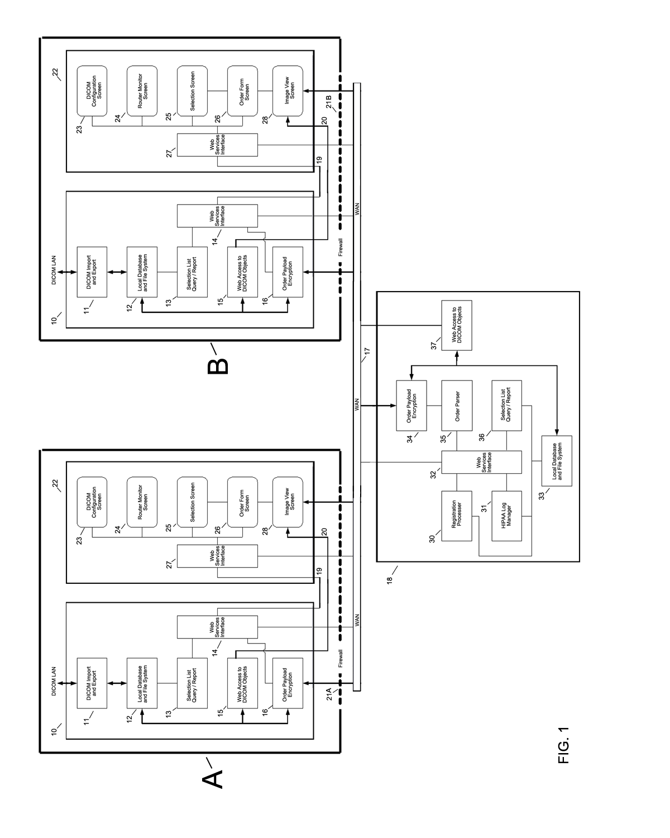
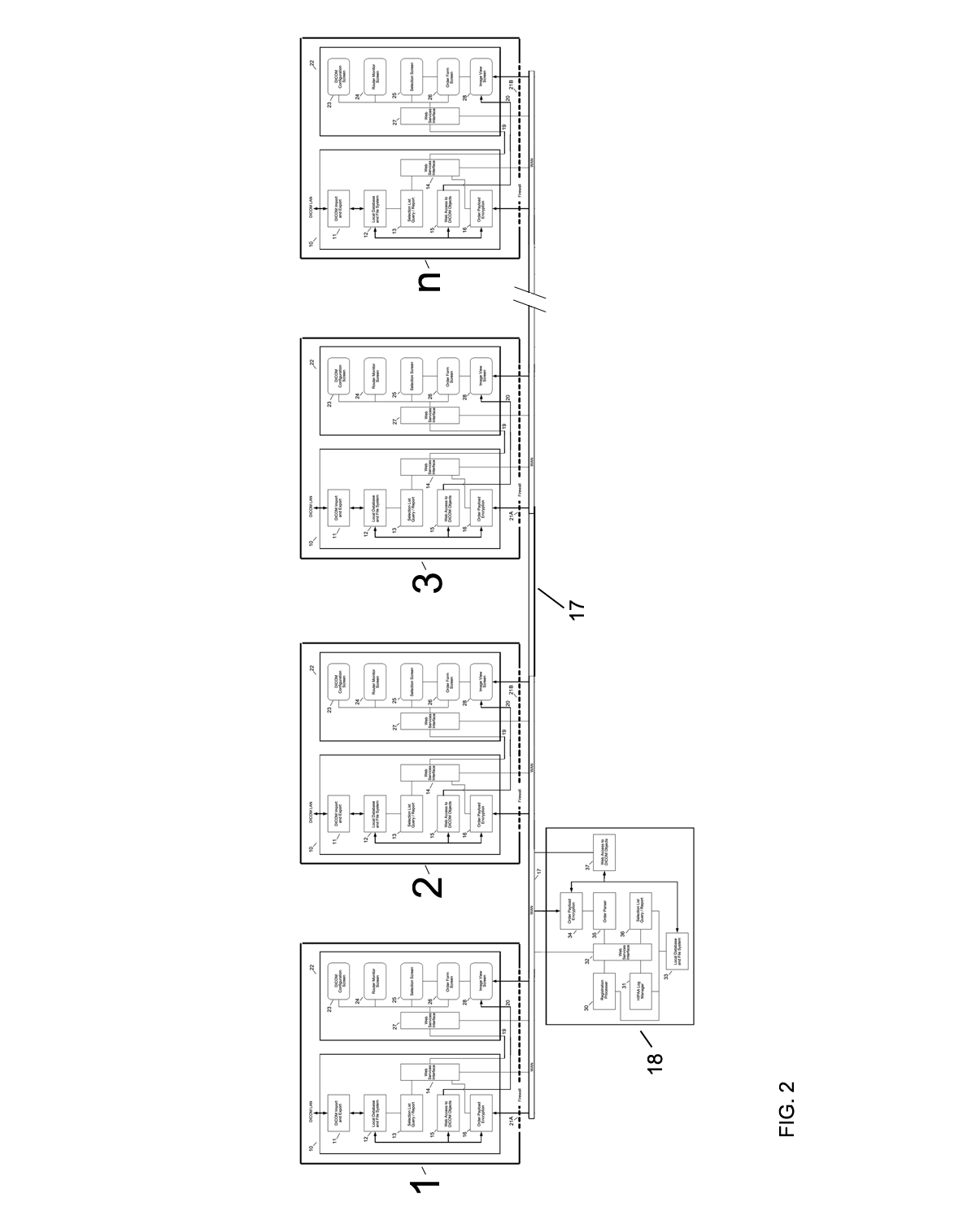
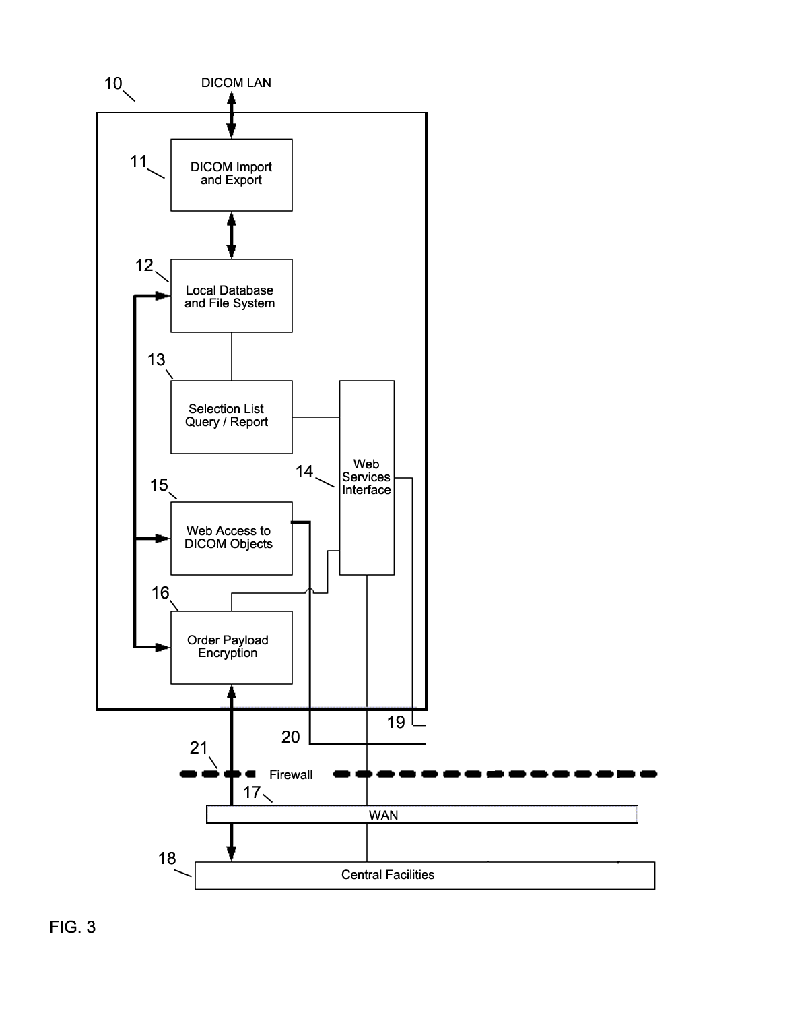
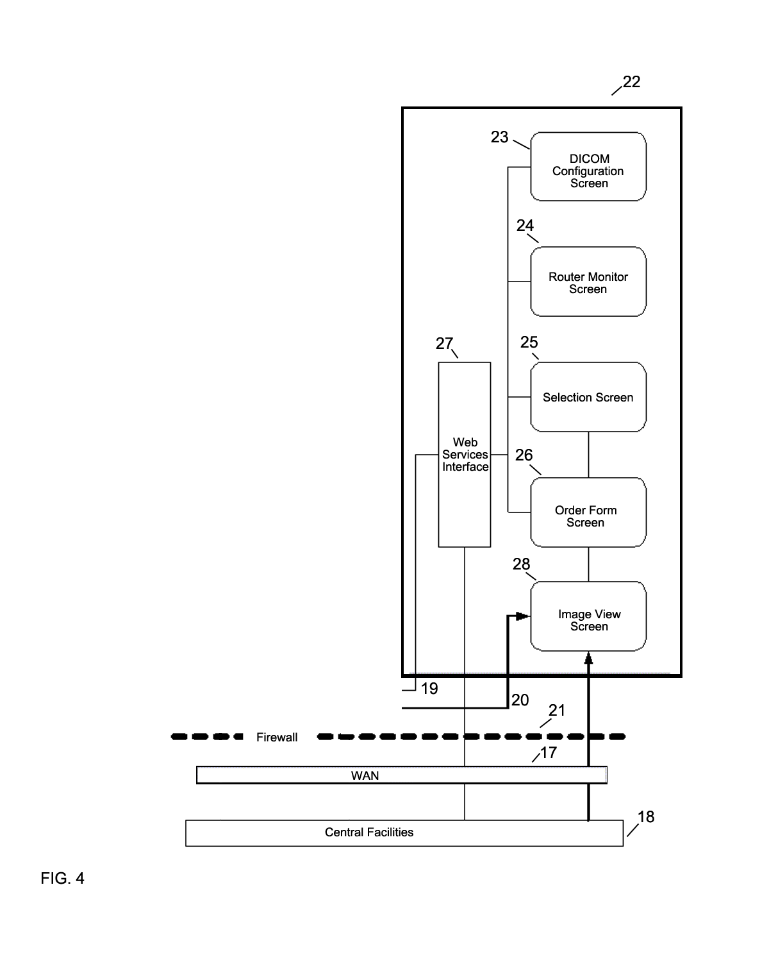
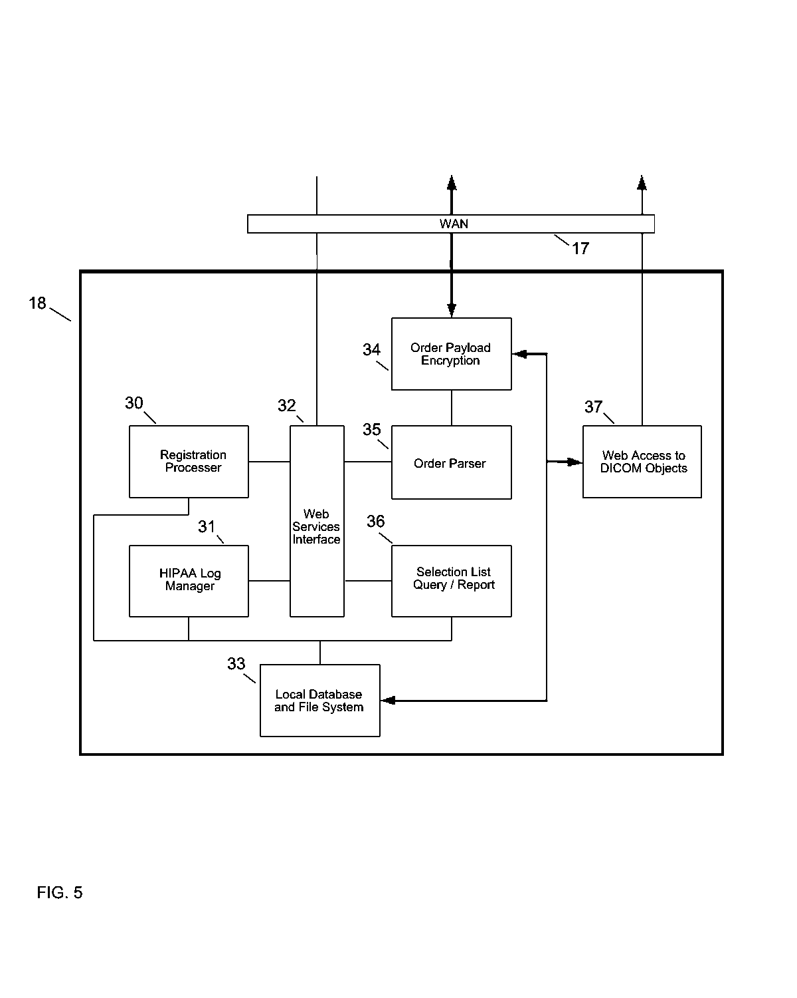
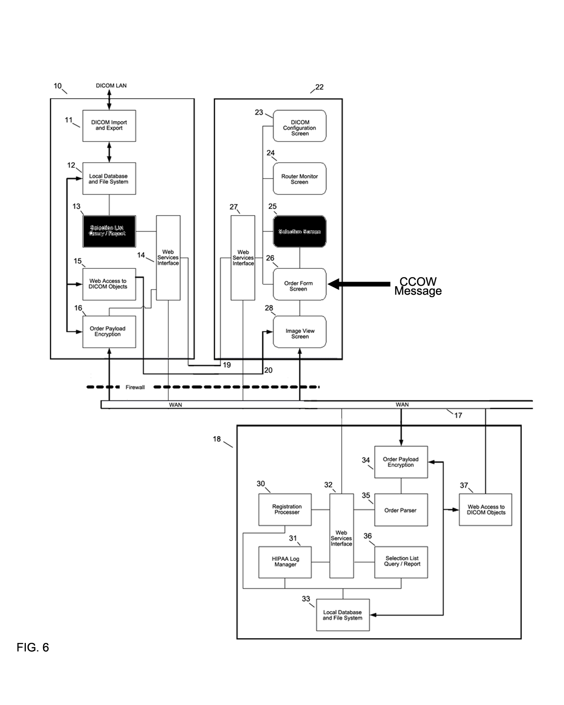

Time | Institution A | Central Facility | Institution B
T₀ | Orders Imaging:  Series X;  Series Y;  Series Z | Transmits Institution A’s Order to  Institution B | All imaging series incomplete and  unavailable to send.
T₁ |  | Holds  Series X | Series X complete  Sends to  Central Facility
T₂ |  | Holds  Series X;  Series Y | Series Y complete  Sends to  Central Facility
T₃ | Receives Imaging  Series X;  Series Y;  Series Z  and  “Order complete” message | Aggregates and sends  Series X;  Series Y;  Series Z to Institution A  and transmits  “Order complete” | Series Z complete  Sends to  Central Facility

FIG. 7

Time | Institution A | Central Facility | Institution B
T₀ | Orders Imaging:  Series X;  Series Y;  Series Z | Transmits Institution A’s Order to  Institution B | Imaging Series  unavailable to send.
T₁ | Receives Imaging  Series X | Streams  Series X to Institution A | Series X complete  Sends to  Central Facility
T₂ | Receives Imaging  Series Y | Streams  Series Y to Institution A | Series Y complete  Sends to  Central Facility
T₃ | Receives Imaging  Series Z and  “Order complete” message | Streams  Series Z to  Institution A  and transmits  “Order complete” | Series Z complete  Sends to  Central Facility

FIG. 8

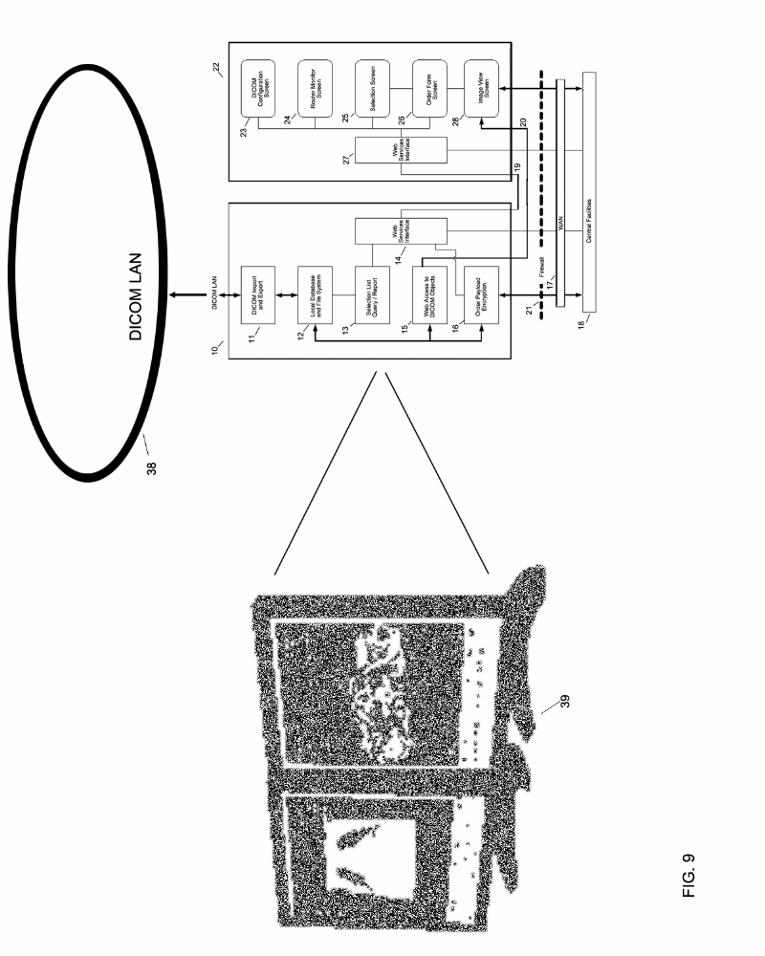
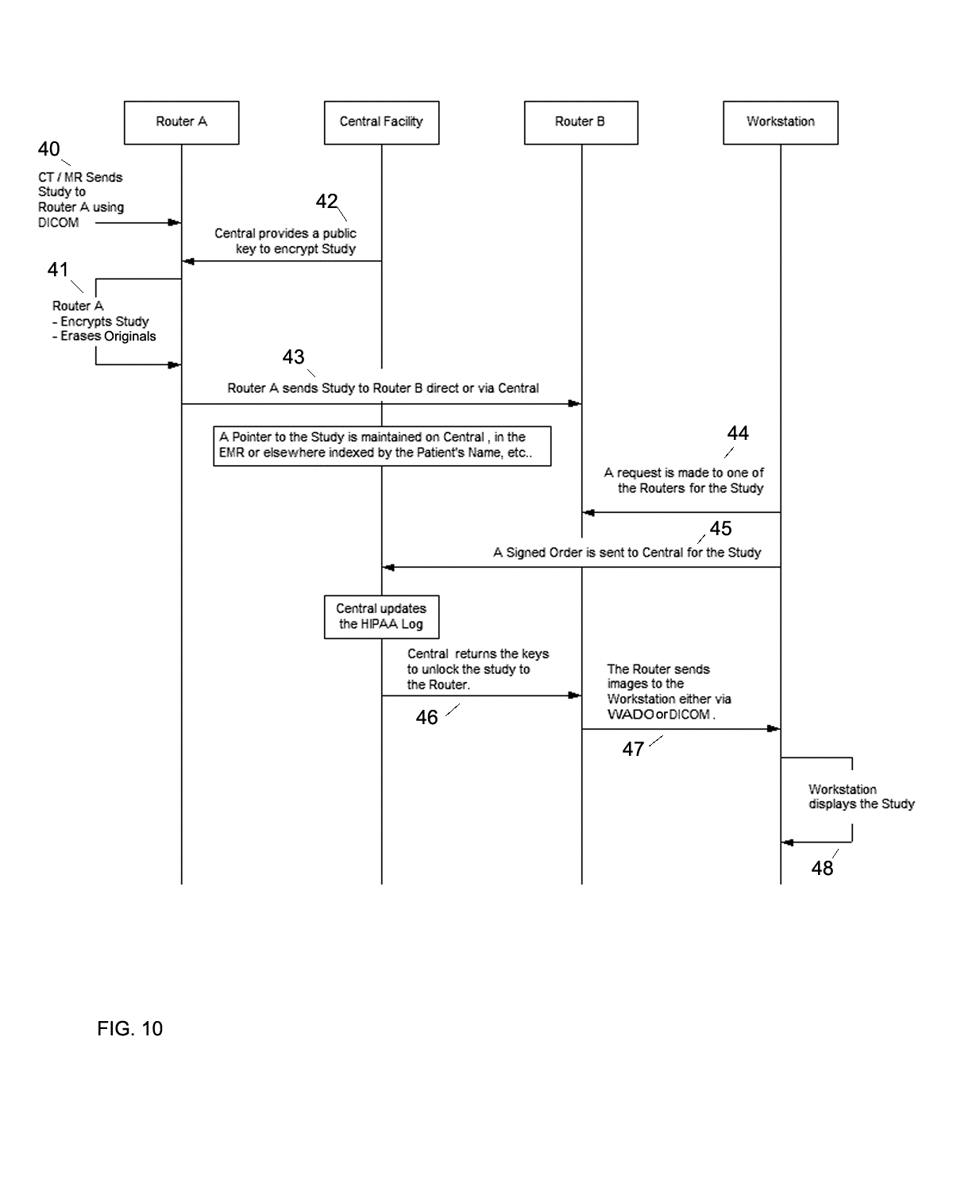
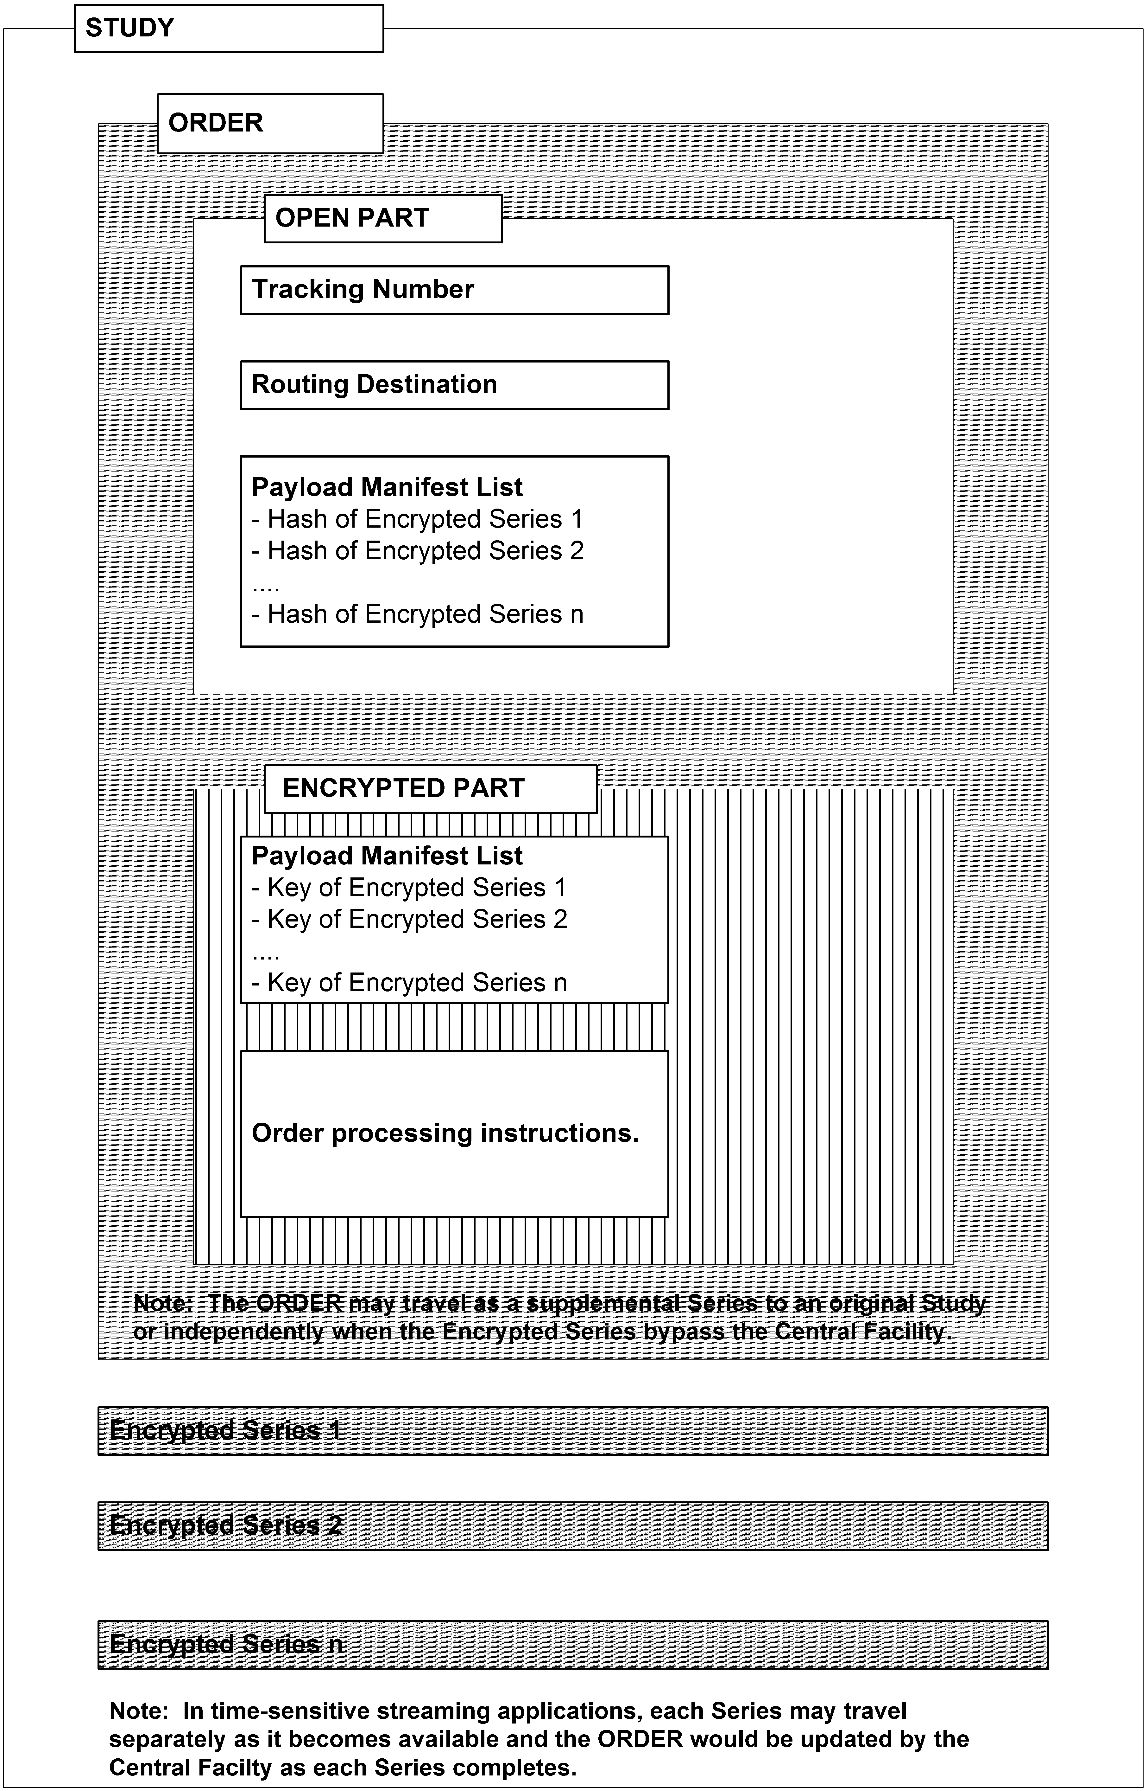
51
52
53
49
50

FIG. 11
BACKGROUND

- The invention relates to the electronic distribution of radiological digital image data such as MR, CT, Ultrasound, X-ray etc.

BRIEF SUMMARY OF THE INVENTION

- The invention is comprised of a system and method to provide a “Virtual Radiology” service. This service potentially can bring any radiological digital image data to any desktop computer or workstation at any institution. The service is “Virtual” due to the fact that the radiological digital image data accessible on the DICOM LAN and PACS of a first institution is made available to a second institution without either institution having to open their networks to each other, establish legal or other business relationships and understandings or to become administratively involved with each other. The system includes an intermediary Central Facility which isolates each institution from all others and which maintains such centralized records of all data transfers and security to comply with applicable regulatory laws (such as HIPAA). The invention further includes a method by which the intermediary Central Facility manages the encryption of data and the encryption / decryption keys between all institutions involved in the transfer of radiological digital image data. The method of the invention further supports the speculative transmission of radiological digital image data to institutions.

- It is an object of this invention to provide a system that can “virtually” connect the DICOM LAN and PACS of a first institution to the DICOM LAN and PACS of a second institution.

- It is another object of this invention to provide a system that includes an intermediary Central Facility that manages the “virtual” connection.

- It is yet another object of this invention to provide a method for security where an intermediary Central Facility manages the keys for the encryption and decryption of the radiological digital image data that is transferred between institutions.

- It is a further object of this invention to provide a method where an intermediary Central Facility maintains such centralized records of all transfers of radiological digital image data between all institutions as necessary for regulatory compliance of the institutions involved in the transfers of the radiological digital image data.

- It is still a further object of this invention to provide a method where the radiological image data can be transferred speculatively between institutions.

BRIEF DESCRIPTION OF THE DRAWINGS

- FIG. 1 is a system diagram showing the logical connections between two institutions and the central facility

- FIG. 2 is a system diagram showing a multiplicity of institutions connected to the central facility.

- FIG. 3 is a diagram of the logical elements of the system router component.

- FIG. 4 is a diagram of the logical elements of the system access interface component.

- FIG. 5 is a diagram of the logical elements of the system central facility.

- FIG. 6 is a diagram of the logical elements of the router, access interface, and central facility in an operational variation utilizing CCOW.

- FIG. 7 is a table detailing a first method of transfer of data between institutions and the central facility where the data is aggregated by the central facility.

- FIG. 8 is a table detailing a second method of transfer of data between institutions and the central facility where the data is streamed by the central facility.

- FIG. 9 shows the system connected to a DICOM LAN of an institution while functionally appearing similar to a typical modality connection such as a workstation.

- FIG. 10 is a diagram detailing the flow of data, orders, encryption keys, and requests for studies between two routers, the central facility and a workstation.

- FIG. 11 is a diagram of the logical elements included in a transmitted Study.

DETAILED DESCRIPTION OF THE INVENTION

- Referring to FIG. 1 the invention is comprised of a system and a method for electronically moving DICOM data between institutions A and B under the control of an intermediary Central Facility 18. The pre-requisite for the implementation of the invention is the existence of a computer on the institutional DICOM LAN under the control of a User that has DICOM Picture Archiving and Communication System (PACS) access privileges. For example, the user would be allowed by the institution to install and operate a DICOM workstation.

- The institutions A and B and Central Facility 18 communicate over a WAN 17, which typically is the Internet. The elements of the system are comprised of router 10, access interface 22 and intermediary Central Facility 18.

- Referring to FIG. 3, FIG. 4 and FIG. 5 a DICOM Configuration Screen 23 configures the Router 10 to join the DICOM network. The DICOM Import and Export 11 is used to populate and update a Local Database and File System 12 of imaging studies in accordance to the user’s privileges and role relative to the PACS. The Local Database and File System 12 provides temporary storage of imaging studies and items such as pending orders that might be the subject of a transfer. A Selection List Query / Report 13 responds to parameters entered by the User on Selection Screen 25 with a report that populates a list on the Selection Screen 25with items from Local Database and File System 12. Alternate embodiments would build a Selection List Query Report 13 by a query to the PACS directly. Web Services Interface 14 and 27 relay messages between the Router 10 and Access Interface 22 using standard protocols over LAN connections 19 and 20. The Router 10 can be located on a different computer form the Access Interface 22 and multiple Access Interfaces 22 can communicate with multiple Routers 10.

- In use the User picks one or more items from the Selection Screen 25. Each item typically represents a DICOM Study. The item(s) selected populate the payload field of an instance of an Order as displayed on the Order Form Screen 26. Information such as the Patient’s name, and Referring Physician are derived from the DICOM Study metadata and can be used to populate other fields of the Order Form Screen 26. Furthermore, the Order Form Screen 26 can use the Web Services Interface 27 to fetch additional information form the intermediary Central Facility 18 by using Patient, Physician and other information such Procedure that is available in the DICOM metadata.

- An Image View Screen 28 is available to the User for quality control purposes during the Order creation process. A Web access to DICOM Objects (WADO) 15 module supports the Image View Screen 28. Alternate embodiments would have DICOM access to the Router 10 by a Diagnostic or 3D Workstation or could access images directly from the Local Database and File System 12.

- Finalization of the Order, as communicated via the Web Services Interface 14, triggers the Order payload encryption 16 to package the payload and Order information for transport over the WAN to the intermediary Central Facility 18. In alternate embodiments, transport of Order and Payload are subject to various optimizations such as the encryption and speculative streaming of DICOM images as they come in or the use of image compression. A wireless WAN module in the Router 10 can provide an alternative way to bypass the institutional firewall.

- The intermediary Central Facility 18 provides temporary buffering and routing for studies of the way to Routers 10 at other facilities. Orders are typically decrypted and re-encrypted with keys that are specific to the destination Router 10. Payload metadata may be examined to assist in routing if the Order Form itself does not have sufficient information. Payload images and reports are made available directly to Web browsers using a WADO module 37 at the intermediary Central Facility 18. The intermediary Central facility 18 keeps a HIPAA log of transfers that is accessible to the Patient and to other authorized Users and further provides long term archiving. The intermediary Central Facility 18 allows the speculative capture of images accompanied by incomplete or poorly specified Order Forms. Manual intervention can be used to update and finalize an Order. The intermediary Central Facility 18 is designed in a way that is compatible with transport and storage of payloads that are encrypted with keys that are not available to the intermediary Central Facility 18.

- Referring to FIG. 1 and FIG. 5 the intermediary Central Facility 18 services requests that come in though the Web Services Interface 32 from a typical Web browser and Web Access to DICOM Objects 37 and via Order Forms that travel with DICOM payloads. The Registration processor 30 is used to create and update a User or Institution profile in the Local Database and File System 33. The Registration Processor 30 can provide information about a User (Patient, Physician) or Institution as an Order Form is being filled out to improve the reliability and security of Order processing. The Registration Processor 30 is also able to issue Tracking Numbers to confirm an acceptable Order and as a Pre-requisite to finalizing an Order Form. A finalized Order Form is one that has been confirmed by both the intermediary Central Facility 18 and the User. Intermediary Central Facility 18 confirmation is typically associated with the issuance of a Tracking Number. User confirmation is typically associated with an electronic signature on the Order Form. A credit card transaction is optionally associated with the finalization of the Order Form and may be processed by the Registration Processor 30 or by a separate charge capture mechanism. A finalized Order Form arrives at the intermediary Central Facility 18 in association with an encrypted payload. The Order Parser 35 interprets visible and hidden fields of the Order Form as storage and routing instructions. If an Order is incomplete or otherwise inadequate, the payload may be sequestered pending additional manual intervention. The Order Parser 35 directs the Order Payload Encryption 34 module to decrypt the payload for storage in the Local Database and File System 33. Alternatively, payloads may be stored without decryption. The Order Parser 34 directs the Order Payload Encryption module 34 to encrypt the payload with a new key associated with the destination Router and User. The Order Payload Encryption module 34 can then forward the payload to the destination Router using protocols appropriate to WAN transport of large objects. A registered User may access Studies and in-process Orders via the Selection List Query / Report 36 accessed through Web Services or directly from a Web Browser. A Study listed in a Selection List Query / Report 36 can be viewed directly from the intermediary Central Facility via the WADO viewer 37. Intermediary Central Facility 18 WAN transport protocols include Web Services over HTTP and HTTPS, direct HTTP (S) interactions with Web Browsers and other protocols that are more appropriate to the transport of Binary Large Objects. It is assumed that most Routers 10 and Access Interfaces 22 will be located behind firewalls 21, 21A, 21B that the intermediary Central Facility 18 has no control over. To cross firewalls 21,21A, 21B with little or no reconfiguration, Routers 10 work in with the Intermediary Central Facility 18 in a manner that allows the Routers 10 to initiate transfers either as a result of User actions or automatically using a polling mechanism.

- The system has been specifically designed and configured to partition the health care specific elements which function in accordance with health care related standards, such as DICOM, from the non health care related components which function in accordance with standards other than health care standards. This partitioning is expressed in the health care related components of the system being associated with the router 10 and non health care components being associated with access interface 22. This design enables generalizable development of the non-health care related components such as security, certificate signing, workflow, etc.

- FIG. 2 depicts the connection of any number (1, 2, 3, n) of numerous institutions connecting to the intermediary Central Facility 18. The primary connection of each institution is to the intermediary Central Facility 18. The institutions have no functional direct connection to each other and without the actions and management of the intermediary Central Facility 18 no usable data transfers occurs. In alternate embodiments employing the direct transfer of encrypted payload components between institutions the transferred components are not useable until a matching Order arrives from the Central Facility 18.

- A variation of the utilization of the system is shown in FIG. 6. The acronym CCOW stands for "Clinical Context Object Workgroup”, a reference to the standards committee within the HL7 group that developed the standard. CCOW is a vendor independent standard developed by the HL7 organization to allow clinical applications to share information at the point of care. Using a technique called "context management"; CCOW allows information in separate healthcare applications to be unified so that each individual application is referring to the same patient, encounter or user. CCOW works for both client-server and web-based applications. This means that when a clinician signs onto one application within a CCOW environment, and selects a patient, that same sign-on is simultaneously executed on all other applications within the same environment, and the same patient is selected in all the applications, saving clinician time and improving efficiency. As shown in FIG. 6 in a facility where the Electronic Medical Record (EMR) or PACS supports CCOW, the entire selection process 13 and 25 might be eliminated. A patient or study focus in the EMR will be communicated directly and automatically to the Order Form Screen 26.
- The precise action of the intermediary Central Facility 18 with regard to the actual transfer of radiological digital image data is flexible and can be adjusted to suit the institutions involved. FIG. 7 is a table showing the nature of the data transfer with respect to two institutions and time. When the data is initially requested by institution A it is unavailable at institution B. Subsequently, as the data becomes available, institution B transfers Series X, Series Y, Series Z to the intermediary Central Facility which holds and aggregates the Series X,Y and Z until complete and then transfers the data to institution A.

- FIG. 8 is a table similar to FIG. 7, which again shows the nature of data transfer with respect to two institutions and time. As in FIG. 7 when the data is initially requested by institution A it is unavailable at institution B. In FIG. 8 rather than hold and aggregate the data the intermediary Central Facility streams the data to institution A contemporaneously as it is received from institution B. An alternate embodiment allows the image data, but not the Order, to bypass the Central Facility 18. The Order 50 (FIG. 11) may travel as a supplemental Series to an original Study or independently when the Encrypted Series bypass the Central Facility 18. In time-sensitive streaming applications, each Series may travel separately as it becomes available and the Order 50 would be updated by the Central Facility 18 as each Series completes.

- The intermediary Central Facility manages the data transfer between institutions and could also effect, through the appropriate management of encryption / decryption keys, the direct transfer of data (aggregated or streamed) from institution B to institution A or the reverse.

- An important aspect of the system is its “Virtual” nature. Institutional networks are complicated by technical, administrative, legal, and regulatory requirements. Opening up these networks directly to each other is a problem so daunting that it is simply not practical. As shown in FIG. 9 the system 10, 22, 21, 17, 18 of the present invention effects a routine connection to an institution’s DICOM LAN 38 in a manner that makes the entire system of the present invention appear as a “Virtual Modality” similar to a workstation 39 or any other modality on the DICOM LAN 38 requiring just routine technical, administrative, legal or regulatory involvement.

- FIG. 10 generally depicts the method of the invention. Router A refers to the part of the system that is behind the firewall in institution A and Router B refers to the part of the system that is behind the firewall in institution B. The Workstation can be anywhere in the system. Starting at 40 a CT/MR etc. sends a Study to Router A using DICOM. At 41 Router A encrypts the Study with a public key provided at 42 by the Central Facility. Router A then sends 43 the Study to either the Central Facility or Router B. At 44 and 45 a request is made to Router B for the Study and a signed Order is sent to the Central Facility for the Study. The Central Facility at 46 updates the HIPAA log and returns the keys to Router B to unlock the Study. Router B sends 47 the Study to the Workstation via either WADO or DICOM. At 48 the Workstation displays the Study.

- As part of the method the intermediary Central Facility 18 manages encryption which is done primarily by the routers 10. Referring to FIG. 11, each Series 53 is encrypted with its own random Key. The Key will travel with the Order 50. Each Series 53 has a Hash calculated prior to encryption at the origin that validates its contents. In addition, calculating a second Hash of the encrypted Series 53 enables validation of integrity during intermediate transfers without compromising security because the second Hash can be recalculated at each intermediate point. Calculations of the Hash are facilitated by the use of standard algorithms such as SHA-1.

- Referring to FIG. 10 and FIG. 11. The Order 50 is an XML document, which has a Closed or Encrypted part 52 and an Open part 51. The Open part 51 lists one Hash for each Series 53 in the Payload. This makes it possible to validate or discard duplicate Series at anytime. The Closed or Encrypted part 52 lists one Key for each Series 53. The Order 50 is always encrypted with the Public key of the destination. When the Order 50 is traveling from Router A to the Central Facility, the Order is encrypted with the Central Facility public key. Where the Order 50 is traveling from the Central Facility 18 to Router B, the Order is encrypted with the public key of Router B. If the Order 50 is considered as a supplemental Series in the payload, then the original Series need not be encrypted with PKI but can use the more efficient symmetric key algorithms and the Central Facility 18 doesn’t have to re-encrypt the original Series.

- As part of the method of the invention, the Central Facility decrypts the Order using its Private Key. The Order is modified to remove fields that Router B should not have or the User should not see. The modified Order is re-encrypted with Router B’s Public key and sent to Router B. A HIPAA Log entry is made that IDs the User, the original Router A Order and the Router B Order. Router B receives the modified Order and attaches it to the appropriate Series by checking the Hashes in the Open part of the Order. Router B de-crypts the Order using its Private Key and can stream the Series to the Workstation using WADO or send it on the LAN using DICOM.

- It will thus be seen that the objects set forth above, among those made apparent from the preceding description, are efficiently attained and, since certain changes may be made in the above construction without departing from the spirit and scope of the invention, it is intended that all matter contained in the above description or shown in the accompanying drawings shall be interpreted as illustrative and not in a limiting sense.

- It is also to be understood that the following claims are intended to cover all of the generic and specific features of the invention herein described and all statements of the scope of the invention which, as a matter of language, might be said to fall therebetween.

We claim:
- A system for virtual radiology comprising in combination a first router and a first access interface and at least a second or more router or routers and at least a second or more access interface or access interfaces and a central facility which manages the transfer of data between the two or more routers over a WAN.

- A system for virtual radiology as claimed in claim 1 where the first router is connected to the DICOM LAN behind the firewall of a first institution and a WAN and a second router is connected to the DICOM LAN behind the firewall of a second institution and a WAN.

- A system for virtual radiology as claimed in claim 2 where the first router and second router communicate with a central facility, which manages data transfer via a WAN.
- A system for virtual radiology as claimed in claim 3 where the central facility is not behind the firewall of the first institution and not behind of firewall or firewalls of the second or more institution or institutions.

- A system for virtual radiology as claimed in claim 4 where the central facility manages a multiplicity of routers behind a multiplicity of firewalls at a multiplicity of institutions.

- A system for virtual radiology as claimed in claim 5 where the data being transferred is a DICOM series or a multiplicity of DICOM series.

- A system for virtual radiology as claimed in claim 6 which includes an order document with an open part and a closed part.

- A system for virtual radiology as claimed in claim 7 where the open part of the order document is not encrypted.

- A system for virtual radiology as claimed in claim 7 where the closed part of the order document is encrypted

- A system for virtual radiology as claimed in claim 7 where the order document is an XML document.

- A system for virtual radiology as claimed in claim 7 where the open part lists one Hash for each series.

- A system for virtual radiology as claimed in claim 7 where the closed part lists one decryption Key for each series.

- A system for virtual radiology as claimed in claim 7 where the central facility uses a Private Key to decrypt the order document.

- A system for virtual radiology as claimed in claim 7 where the central facility provides a Public Key to encrypt the order document.

- A system for virtual radiology as claimed in claim 7 where the receiving institution provides a public Key to encrypt the order document.

- A system for virtual radiology as claimed in claim 7 where the receiving institution uses a Private Key to decrypt the order document.

- A system for virtual radiology as claimed in claim 7 where the functionality of the access interface or access interfaces is provided automatically using methods that are associated with IHE or CCOW.

- A method for virtual radiology comprising the steps of:
- sending a public key, which is used to encrypt a Study, from a central facility to a router behind the firewall of a first institution;
- receiving at the central facility the encrypted Study from the router behind the firewall of the first institution;
- receiving at the central facility an order from a second router behind the firewall of a second institution for the Study received from the first router behind the firewall of the first institution;
- re-encrypting by the central facility, the Order for the Study received from the first router behind the firewall of the first institution, with the public Key of the second institution;
- sending the re-encrypted Order for the Study and the Study to the second router behind the firewall of the second institution.

- A method for virtual radiology comprising the steps of:
- sending a public key, which is used to encrypt a Study, from a central facility to a router behind the firewall of a first institution;
- receiving at the central facility the encrypted Study from the router behind the firewall of the first institution;
- re-encrypting by the central facility, the Order for the Study received from the first router behind the firewall of the first institution, with the public Key of a second institution ;
- speculatively sending the re-encrypted Order for the Study and the Study to the second router behind the firewall of the second institution.

- A method for virtual radiology comprising the steps of:
- sending a public key, which is used to encrypt a Study, from a central facility to a router behind the firewall of a first institution;
- receiving at the central facility the encrypted Study from the router behind the firewall of the first institution;
- re-encrypting by the central facility, the Order for the Study received from the first router behind the firewall of the first institution, with a multiplicity of public Keys of a multiplicity of institutions ;
- speculatively sending the re-encrypted Order for the Study and the Study to a multiplicity of routers behind a multiplicity of firewalls at a multiplicity of institutions.

- A method for virtual radiology as claimed in claim 18 and including after step (e) recording, by the central facility, an entry in a HIPAA log detailing the transfer of the Study or Studies from the first institution to the second institution.

- A method for virtual radiology as claimed in claim 19 and including after step (d) recording, by the central facility, an entry in a HIPAA log detailing the transfer of the Study or Studies from the first institution to the second institution.

- A method for virtual radiology as claimed in claim 20 and including after step (d) recording, by the central facility, an entry in a HIPAA log detailing the transfer of the Study or Studies from the first institution to a multiplicity of institutions.

- A method for virtual radiology as claimed in claim 18 and including before step (b) assigning, by the central facility, a tracking number to the order.

- A method for virtual radiology as claimed in claim 19 and including before step (b) assigning, by the central facility, a tracking number to the order.

- A method for virtual radiology as claimed in claim 20 and including before step (b) assigning, by the central facility, a tracking number to the order.

- A system for virtual radiology as claimed in claim 7 where health care specific components functioning in accordance with health care specific standards are partitioned and associated with the router component of the system and the non health care specific components, functioning in accordance with standards other than health care specific standards, are associated with the access interface.
ABSTRACT

The invention is comprised of a system and method to provide a “Virtual Radiology” service. This service potentially can bring any radiological digital image data to any desktop computer or workstation at any institution. The service is “Virtual” due to the fact that the radiological digital image data accessible on the DICOM LAN and PACS of a first institution is made available to a second institution without either institution having to open their networks to each other, establish legal or other business relationships and understandings or to become administratively involved with each other. The system includes an intermediary Central Facility which isolates each institution from all others and which maintains such centralized records of all data transfers and security to comply with applicable regulatory laws (such as HIPAA). The invention further includes a method by which the intermediary Central Facility manages the encryption of data and the encryption / decryption keys between all institutions involved in the transfer of radiological digital image data. The method of the invention further supports the speculative transmission of radiological digital image data to institutions.

